**Concepts of OFDM**

**(Orthogonal Frequency Division Multiplexing)**

Shuihan Liu and Mohamed Ibrahim

Electrical & Computer Engineering, Purdue University

VIP 47920: Beyond 5G

Prof. [Chih-Chun Wang](https://engineering.purdue.edu/~chihw/)

**TABLE OF CONTENTS**

ABSTRACT…………………………………………………………………………...3

1. Introduction of traditional FDM ………………………..…....……………………3
   1. Disadvantage with traditional FDM ………………………………………3
   2. Concepts of ACI (adjacent channel interference).......…………………….4
2. Motivation of OFDM ………………………………………………….………….4
   1. Key features of OFDM ……………………………………………………4
   2. Orthogonality ………………………………………………………….….4
   3. Synchronization achievement …………...…………………………….….5
   4. Advantages & disadvantages of OFDM ……………………………….….6
3. Role of Cyclic Prefix in OFDM …..…………...…………………………………6
   1. A Brief History of OFDM ………………………………………………...6
   2. Transmission of two consecutive OFDM symbols …………….…………7
   3. Channel Equalization in frequency selective channels ……….…………..8
   4. An illustration of circular convolution ……….…………….……………..8
   5. Description of the CyclicPrefix ………………………..………………....9

REFERENCES ………………………………………………………………………10

**ABSTRACT**

Frequency Division Multiplexing (FDM) is a technique that has traditionally been used to achieve reliable wireless communications over a given bandwidth. However, there are several issues with traditional FDM techniques as for example, they cause a proportion of valuable frequency spectrum to be wasted. OFDM (orthogonal frequency-division multiplexing) is a type of digital transmission which has developed into a popular scheme for wideband digital communication due to its flexibility and satisfactory performance over channels, as well as its efficient use of spectrum. It has applied to various products such as televisions, audio broadcasting, DSL internet access, wireless networks, power line networks, or even 4G/5G mobile communications. In this paper, we analyze OFDM's improvements from FDM, OFDM's motivation, key features about OFDM, and the role of cyclic prefix in OFDM and its detail.

**1. Introduction of traditional FDM**

**1.1 Disadvantage with traditional FDM**

In 1918, modulated carriers with frequency-division multiplexing were introduced in which several different frequencies are transmitted simultaneously over the same line. FDMA is used by analog systems, such as AMPS, NMT, or Radiocom 2000.[4] It has its advantages, such as the complexity of FDMA systems, which is lower than TDMA and CDMA systems, though this is changing as digital signal processing methods improve for TDMA (Time division multiple access) and CDMA (Code Division Multiple Access). Since FDMA is a continuous transmission scheme, fewer bits are needed for overhead purposes than TDMA.[4] However, the reason people nowadays are not using this technology from the beginning of 18 century is apparent - FDM has many disadvantages as well that people may want something to replace it with another more advanced one to satisfy more different purposes of wireless communication.

Firstly, only modest capacity improvements could be expected from a given spectrum allocation. FDMA wastes bandwidth. If an FDMA channel is not in use, it sits idle and cannot be utilized by other users to increase or share capacity. Other than that, On a mobile FDMA unit, it uses duplexers because the transmitter and receiver will work simultaneously, and it adds weight, size, and cost to it.FDMA requires tight RF filtering to minimize adjacent channel interference (ACI).[4]

Figure 1 below shows a basic FDM scheme that can divide a channel into many sub-channels and let each user occupy one simultaneously.

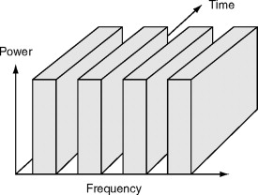

Figure 1: Frequency-Division Multiple Access (FDMA) [4]

**1.2 Concepts of ACI (adjacent channel interference)**

As we mentioned above about the disadvantages of traditional FDM systems, we indicate one of its disadvantages, which can lead to ACI (adjacent channel interference).

The signal adjacent in frequency to the desired signal will cause ACI. This signal can pass the bandpass filter because it is a nearby frequency.

ACI can be reduced by :

1. Using modulation schemes that have low out-of-band radiation.[4]
2. Redesign the bandpass filter at the receiver end.[4]
3. Assign adjacent channels to different cells to keep the frequency separation between each channel in a given cell as large as possible.[4]
4. Use advanced techniques that employ equalizers.[4]
5. The maximum bit rate of each channel is fixed and small.[4]

**2. Motivation of OFDM (Orthogonal frequency division multiplexing)**

**2.1 Key feature of OFDM**

Before introducing OFDM's critical features, OFDM is a multicarrier modulation that is increasingly used in communication systems such as WiFi, 4G/LTE, power line communication, etc.[9] OFDM has a key feature that does not need filters to separate the subbands since the orthogonality is kept among subcarriers, but it requires a guard band such as VCs (Virtual Carriers) to combat the ACI.[8]

**2.2 Orthogonality**

One of the most critical characteristics of OFDM is its orthogonality. In OFDM, the overall signal bandwidth is divided into many subchannels. It switches a wideband frequency-selective fading channel to a series of narrowband and relatively flat subchannels, which require simpler equalization. The orthogonality is achieved by carefully selecting the carrier spacing to be precisely equal to the symbol rate, as illustrated in Figure 2. The orthogonality allows simultaneous transmission on subcarriers in a tight frequency space without interfering with each other. The orthogonal signals can be separated by correlation techniques or by using a conventional matched filter at the receiver. [11]

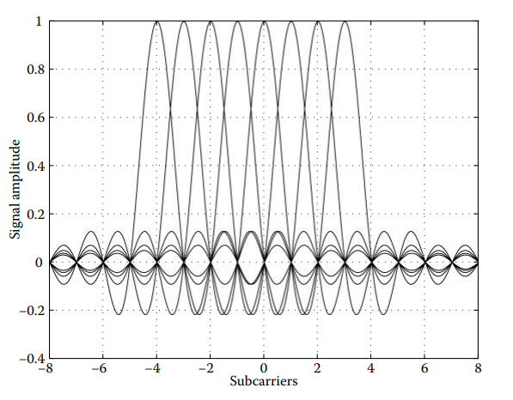

Fig. 2: subcarriers are orthogonal to each other[11]

**2.3 Synchronization achievement**

As discussed in the orthogonality principle in the last section, the OFDM system carries the message data on orthogonal subcarriers for parallel transmission, combating the distortion caused by the frequency selective channel or, equivalently, the inter-symbol-interference in the multipath fading channel. However, the advantage of the OFDM can be useful only when the orthogonality is maintained. In case the orthogonality is not sufficiently warranted by any means, its performance may be degraded due to inter-symbol interference (ISI) and inter-channel interference (ICI) [8]. In this section, we will talk about the three-step procedure for OFDM Timing and frequency synchronization.

First is the so-called synchronization process, which is initiated during the downlink transmission period, with each mobile terminal utilizing a pilot signal transmitted by the base station to undergo frequency and timing estimation. This process reduces synchronization errors to a tolerable range. The predicted parameters on each user can then detect the downlink [data stream and synchronization](https://www.sciencedirect.com/topics/computer-science/data-synchronization) references for the [uplink transmission](https://www.sciencedirect.com/topics/computer-science/uplink-transmission).[9]

After this, frequency and timing estimation is performed in the uplink. This is a challenging task because the uplink waveform consists of a mixture of signals sent by various users, each affected by exclusive synchronization errors. Accordingly, such a signal recovery process in the uplink is a multiparameter estimation problem. Hence, the separation of users should be performed before the synchronization procedure. This can be achieved with an efficient subcarrier assignment algorithm. [9]

After accomplishing the uplink estimation for timing and frequency offsets, restoration for the orthogonality among subcarriers should be employed similarly at the base station. [9]

**2.4 Advantages & disadvantages of OFDM**

As we know what OFDM is and some characteristics of OFDM, we can conclude its advantages and disadvantages. Because it presents several advantages compared with single carrier modulation and classical frequency division multiplexing (Bingham, 1990; Van Nee and Prasad, 2000; Prasad, 2004; Li and Stuber, 2006; Armstrong, 2007)[9]:

* Efficient use of the spectrum because subcarrier orthogonality allows overlap. [9]
* Less sensitive to channel fading. [9]
* Channel estimation and equalization in the frequency domain carries low complexity. [9]
* In frequency-selective fading possibility to avoid the affected. [9]
* subcarriers or to adapt their modulation as a function of their SNR. [9]
* Possibility to avoid inter-symbol interference (ISI) with a cyclic prefix. [9]
* Narrowband interference will only affect a few subcarriers. [9]
* Coexistence with other systems: subcarriers can be turned on/off. [9]

Every system is not perfect. On the other side, OFDM does some weakness:

* OFDM is very sensitive to frequency and phase offsets and timing error that sometimes the orthogonality between subcarriers can be broken.[9]
* OFDM temporal signal has a high peak to average power ratio (PAPR) – Poor efficiency of the PAs. – and signal clipping and distortion degrades the SNR and generates out-of-band emissions.[9].

**3: Role of Cyclic Prefix in OFDM**

**3.1: A Brief History of OFDM**

The general goal that OFDM aims to achieve, i.e. transmission over multiple overlapping but non-interfering channels, is a goal that was sought after by the proponents of the wireless communication field for a long time as they sought out methods to achieve better spectral efficiency in transmission. Robert W. Chang of Bell Labs is credited to have introduced the concept of OFDM in 1966 by describing a set of transmitter filters and channel characteristics required for transmission over bandlimited and orthogonal signals [2]. A few years later, the concept of using efficient FFT algorithms to achieve multicarrier transmission in OFDM was introduced by Ebert and Weinstein [2]. The insight of Ebert and Weinstein is the main driving force behind turning OFDM into a practical method of transmission as it greatly simplified the computation process. These important contributions among several others, did not however include a specification of the use of a cyclic prefix in OFDM, which was introduced by Peled and Ruiz [2], [3], in 1980. The following sections will attempt to explain the motivation behind the introduction of the cyclic prefix and its role in achieving reliable transmission in the OFDM transmission scheme.

**3.2: Transmission of two consecutive OFDM symbols**

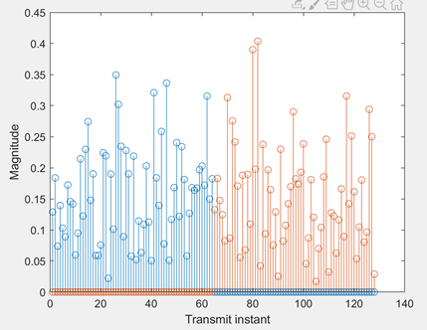

Fig. 3: Two consecutive OFDM symbols with no cyclic Prefix included

Fig.3 above illustrates an example of transmitting two consecutive OFDM symbols with the first symbol shown in blue and the second symbol shown in orange. An important physical phenomenon present in wireless communication channels is multipath propagation, where a transmitted signal arrives at a receiver using multiple paths, and thus multiple copies of a signal arrive at different instances at the receiver. The maximum excess delay in a channel, denoted as Tm is the relative time difference between the first signal component arriving at the receiver to the last component whose power level is above a certain threshold [10]. If Tm > T, where T is the symbol time, a channel can be classified as a frequency selective channel. Wireless channels can be modelled using an impulse response denoted by h[n], and for a given input signal x[n], the signal arriving at the receiver is given by the linear convolution of the channel impulse response and the input signal. Power-delay profiles of a transmission environment can be used to find the impulse response of a channel [11]. Therefore, a received signal at a certain instant y[n] can be described by a difference equation of the form,

y[n] = ax[n] + bx[n-1] + … cx[n - (N-1)] (1)

where a, b and c are coefficients of a channel impulse response of length N. Note that this simplified model does not include additive white gaussian noise, AWGN.

Transmission of OFDM symbols as shown in fig.3.1 in frequency selective channels results in intersymbol interference between two OFDM symbols which reduces the reliability of the communication system. A potential solution to this problem could be to place a guard interval between symbol transmissions such that the length of this interval is larger than the maximum excess delay of the transmission environment [2]. However, the cyclic prefix proves to be a more effective solution as it simplifies the process of channel equalization at the receiver.

**3.3: Channel Equalization in frequency selective channels**

As stated previously, the received signal can be given by the linear convolution of the channel impulse response and the transmitted OFDM symbol. While it is generally known that convolution in the time domain corresponds to multiplication in the frequency domain, in the discrete fourier transform, or DFT, domain, circular convolution in the time domain, and not linear convolution, corresponds to pointwise multiplication in the frequency domain [6]. Suppose the transfer function of the channel is known at the receiver. If we were able to achieve circular convolution between the channel impulse response and the transmitted signal, we would easily be able to determine the effect of the channel on each of the orthogonal subcarriers in OFDM. The effect of the channel would be on each carrier would be described by a single coefficient and thus channel equalization would be performed using a single tap, which greatly simplifies the channel equalization process. To perform this simple equalization process, we first need to find a way to transform the effect of the channel from a linear convolution to a circular convolution.

**3.4: An illustration of circular convolution**

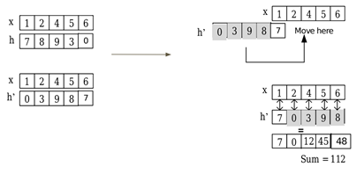

Fig 4.. The process of circular convolution [7]

Fig. 4. shown above illustrates the process of circular convolution of two signals denoted by x and h. Like linear convolution, circular convolution employs a “flip, shift and add” method. However, the difference between linear convolution and circular convolution is that obtaining the output at each instant involves a number of pairs of values from both signals that is equal to the length of the longest signal. As a result, either of the signals needs to be zero-padded so that both signals are effectively of the same length. The signal is also shifted in a circular fashion between as every sample is processed, as shown in fig. 3.4.2.

**3.5: Description of the Cyclic Prefix**

In an OFDM transmission scheme where the number of subcarriers can be represented by N and thus N symbols are transmitted per OFDM symbol, the cyclic prefix involves taking the last L samples of an OFDM symbol and adding them to the beginning of an OFDM symbol, such that the total length of the resulting symbol is N + L. If the length L is at least as long as the estimated channel impulse response, then the cyclic prefix allows us to turn the channel response from a linear convolution to a circular convolution, thus allowing single tap equalization to be used in OFDM.

**REFERENCES**

[1]: R. W. Chang, “High-Speed Multichannel Data Transmission with Bandlimited Orthogonal Signals*,” Bell Sys. Tech. J*., vol. 45, Dec. 1966, pp. 1775–96.

[2]: S. B. Weinstein, "*The history of orthogonal frequency-division multiplexing [History of Communications]*," in IEEE Communications Magazine, vol. 47, no. 11, pp. 26-35, November 2009

[3]: R. Peled and A. Ruiz, “Frequency Domain Data Transmission using Reduced Computational Complexity Algorithms,” Proc. IEEE Int’l. Conf. Acoustics, Speech, and Sig. Proc., 1980, Denver, CO, pp. 964–67.

[4]: M. K. Tsatsanis, (1995), Time-Varying System Identification and Channel Equalization Using Wavelets and Higher-Order Statistics CONTROL AND DYNAMIC SYSTEMS, VOL. 68, Academic Press, Inc. From <https://www.sciencedirect.com/topics/engineering/frequency-division-multiple-access>

[5]: [M. Paetzold, A. Szczepanski, N. Youssef, “Methods for Modeling of Specified and Measured Multipath Power-Delay Profiles,” *IEEE Trans. on Vehicular Techn.*, vol.51, no.5, pp.978-988, Sep.2002.](https://www.researchgate.net/publication/3154876_Methods_for_Modeling_of_specified_and_measured_multipath_power-delay_profiles)

[6]: J. G. Proakis, D. G. Manolakis, *“Digital Signal Processing, 3rd ed”,* Division of Simon and Schuster One Lake Street Upper Saddle River, NJ: Prentice-Hall, Inc, 1996.

[7]: N. Abbasi, “*A simple method to do circular convolution*”, 2018 <https://www.12000.org/my_notes/circular_convolution/index.htm>

[8]: Y. S. Cho; J. Kim; W. Y. Yang; C. G. Kang, "Synchronization for OFDM," in *MIMO-OFDM Wireless Communications with MATLAB®* , IEEE, 2010, pp.153-185, doi: 10.1002/9780470825631.ch5.

[9]: L. Smaini, “*RF Analog Impairments Modeling for Communication Systems*”, Wiley, New York, 2012.

[10]: M.Viswanathan, “*Wireless Communications in MATLAB*”, Independent Publishing, 2020, Accessed on: 05/12/2020. Available: <https://www.gaussianwaves.com/wireless-communication-systems-in-matlab/>

[11]: Jiang, T., Song, L., & Zhang, Y. (Eds.). (2010). *Orthogonal frequency division multiple access fundamentals and applications*. ProQuest Ebook Central <https://ebookcentral.proquest.com/>